**GUIDELINES FOR PUBLIC AND CORPORATE CONTRACTORS**

|  |  |
| --- | --- |
| **AIR CONDITIONING**  UPDATE: April 2021 | F:\TOP TEN PERU\AIRE ACONDICIONADO\TOP TEN AIRE ACONDICIONADO\AIRE ACONDICIONADO IMAGENES\LGVR122H9.JPG |

**WHY ADOPT THE TOPTEN CRITERIA?**

* Topten is an initiative based on active web portals in different parts of the world that helps professionals, public contractors and large buyers to find the most energy-efficient products available in each country. Products are continuously selected and updated according to their energy efficiency and environmental performance. This is independent of manufacturers.
* All washing machines shown on www.topten.pe meet the criteria contained in these guidelines. Therefore, buyers can use the website to check the availability and variety of products currently on the market that meet Topten's selection criteria.

**HOW MUCH CAN YOU SAVE?**

At www.topten.pe washing machines are divided into the following categories:

|  |
| --- |
| AIR CONDITIONING |
| Air conditioning cold |
| Air conditioning hot-cold |

Taking into account the models listed in Topten and the following considerations, it is possible to achieve the savings indicated in the table below.

|  |  |
| --- | --- |
| Consideraciones | * Lifetime: 15 year |
|  | * Electricity cost: 0.5 S/./kWh |



Topten models consume 50% less energy, compared to inefficient models and with savings of S/. 148/unit during its useful life.

**PURCHASING CRITERIA**

In the listings on the website, Topten Peru selects the air conditioning models with the lowest consumption and highest energy efficiency, according to the manufacturer's technical data sheet and based on the selection criteria of the Peruvian technical regulation.

Topten's selection criteria are mentioned and can be inserted in the bidding documents:

**SUBJECT: ENERGY EFFICIENT AIR CONDITIONERS.**

**TECHNICAL SPECIFICATIONS**

* **Cooling / heating capacity (kW):** Maximum cooling / heating capacity in kilowatts (kW), according to the energy label.
* **Sound power Indoor / outdoor unit:** Sound power level of the indoor and outdoor unit for cooling function in dB (A), according to the declaration on the energy label.
* **Refrigerant / GWP:** Name of the refrigerant and its global warming potential. The most common is R410A, a fluorinated refrigerant with a high GWP of 1975.
* **Indoor / outdoor unit size:** Size of the two units in mm (e.g. width x depth x height).
* **EEEI:** The Cooling Energy Efficiency Ratio is the ratio of the cooling capacity (C cooling) to the electrical input power (P) of the appliance when operating in cooling mode at full load. The higher this number, the more efficient the equipment is. It is specified on the Air Conditioner Energy Efficiency Label.
* **Energy efficiency rating**: The energy efficiency rating for air conditioners exclusively with cooling function is determined as set out in the following tables:

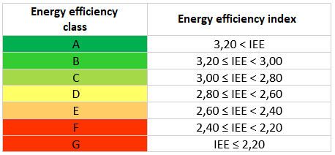

* **Cooling function efficiency (SEER):** The Seasonal Energy Efficiency Ratio (SEER) indicates the energy efficiency of the cooling function. It is calculated based on various part-load measurements in accordance with the energy labeling regulation. The higher the SEER, the more efficient a product is.
* **SCOP heating function efficiency:** The seasonal coefficient of performance (SCOP) indicates the energy efficiency of the heating function. It is calculated analogous to the SEER. The higher the SCOP, the more efficient a product is.

The SEER and SCOP measure the seasonal energy efficiency taking into account seasonal conditions.

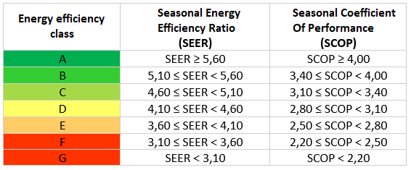The following table shows the energy efficiency ratings for air conditioners based on the SEER and SCOP indices:

**PURCHASING TIPS**

* Choose products with an A-class energy label.
* Choose an equipment with Inverter technology.
* The recommended capacity of the air conditioning equipment (which appears on the energy efficiency label) depends on the size of the room to be air conditioned:



Windows reduce the thermal insulation capacity of a room, so the amount and surface area of windows determines which equipment best suits your needs. Therefore, it is important to provide protection, such as curtains, awnings, or shade from buildings or trees.

To find out which equipment best suits your needs, consider the climate of the area.

It is always best to consult a professional about the best equipment to meet the needs and characteristics of the rooms to be air conditioned.

**ADVICE AND SUPPORT**

For further assistance in using the information presented, please contact the Topten national team (find links at www.topten.pe).

|  |  |
| --- | --- |
| WWF | The elaboration of these procurement guidelines has been supported by funding from WWF Switzerland. The sole responsibility for the content of the Topten procurement guidelines lies with the authors. |

|  |  |
| --- | --- |
| Ein Bild, das ClipArt enthält.  Automatisch generierte Beschreibung | Topten ACT has received funding from the [European Union's Horizon 2020 research and innovation programme](https://ec.europa.eu/programmes/horizon2020) under grant agreement nº649647. The sole responsibility for the content of the Topten Pro procurement guidelines lies with the authors. It does not necessarily reflect the opinion of the European Union. Neither EASME, nor European Commission and project partners are responsible for any use that may be made of the information contained therein. |